Press release attachment

A display of the most interesting collection items from the Chinggis Khan exhibition at the National Museum of the Czech Republic

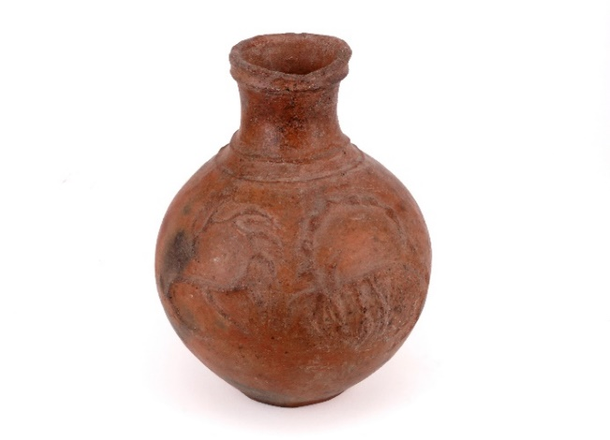

Vessel with deer and ibex
(the oldest object on display within the Chinggis Khan exhibition)
Iron Age
/Institute of Archaeology of Mongolian Academy of Sciences/
The Chandmani culture was widespread in north-western Mongolia and southern Siberia during the Iron Age. It has been dated to the 7th to 3rd century BCE and was discovered in the 1970s. According to skeletal remains, it is clear that the people of this culture rode horses, were used to fighting and consumed dairy products.

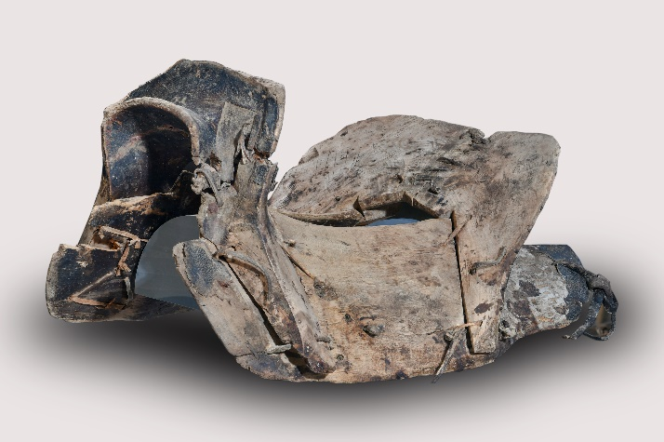

Wooden horse saddle
1264–1300
/Chinggis Khaan National Museum/
The development of the horse saddle had an extraordinary impact on warfare in the ancient cultures of Eurasia. As iconographic sources show, initially the riders sat directly on the horse’s back, which may have been covered with a rug, with their legs hanging freely. It is clear from archaeological findings that they used to have damage to their lower limbs, pelvis and lower spine. The horse’s spine also suffered from the pressure of a seated rider.
The discovery of the saddle and later stirrups, which are still used in horse riding today, led to significant progress. In the middle of the 1st millennium BCE, a soft saddle made of leather or textiles began to be used. This innovation led to greater rider comfort. Firm saddle parts were also appearing, especially the pommel at the front. Later, a saddle with a solid frame came into use, which allowed the rider to sit higher, above the horse’s back, and not weigh down as much on it. The Mongolian composite saddle consists of two side parts, front and back pieces, which are connected by a leather strap. Stirrups were attached to the saddle – a further technological improvement. A rider in the saddle and with stirrups was far more agile and confident in both riding and combat.

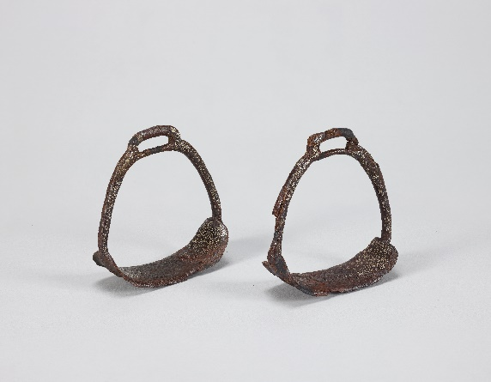

Stirrups decorated with gold wire
(the rarest object on display within the Chinggis Khan exhibition)
13th–14th century
/Institute of Archaeology of Mongolian Academy of Sciences/
These stirrups are decorated with gold filigree with the same depiction of mountains, waters, clouds and trees. In addition, one stirrup is decorated with a plant motif, the other with an animal. The Tavan Tolgoi archaeological site in south-eastern Mongolia is notable for burial mounds dating back to different historical periods. The finds date from the Stone Age through to the 13th and 14th centuries. Along with the development of the horse saddle, various options appeared for securing the rider’s legs while riding. Frescoes from Chinese tombs from the 3rd and 4th centuries CE show that riders used some kind of leather or cloth
bags attached to the saddle, into which they slipped their legs. The earliest metal stirrups come from China around the 4th century CE. At first this was just a single stirrup used to mount the horse. The two stirrups that still aid riders today began to be used in the 4th century by nomadic tribes inhabiting present-day Mongolia and northern China.

Gold jewellery with turquoise
Hun period (3rd century BCE – 2nd century CE)
/Chinggis Khaan National Museum/
The first investigations at the Gol Mod site began in the 1950s. New research has been under way since the beginning of the 21st century, for example the Franco-Mongolian investigations from 2000 to 2010. During this decade, nearly 500 tombs from the Hun period have been uncovered here, including three tombs of the social elites and more than forty satellite tombs, which have yielded some of the most important finds associated with the culture of the Huns. Most of the tombs were looted in the past, yet a number of artistically valuable objects have nonetheless been discovered in them. Frequent finds in elite tombs include parts of horse harnesses, bronze vessels, jade objects, lacquer bowls, and gold plate ornaments that served as coffin decorations. Tomb No. 20, where these golden flowers were found, represents the burial site of the elite of the time. It was significantly damaged: the bronze vessels were broken, the golden four-leaf clovers, which originally decorated the coffin, had been peeled off, but many objects were nevertheless left in it. These six flowers lay behind the head of the coffin. Because there are wires on their reverse side, they were probably originally attached to a solid base. The goldsmith’s work demonstrates a high knowledge of metal working and the craftsmanship of the artists. A number of deposits in Mongolia have revealed high quality turquoise.

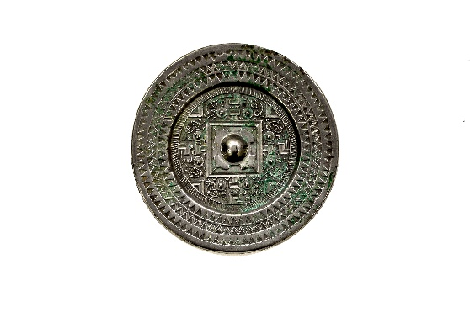

Mirror
Hun period (3rd century BCE – 2nd century CE)
/Chinggis Khaan National Museum/
This type of mirror was used in China from the 2nd century BCE to the 2nd century CE. The mirrors are circular, smooth on one side, and have a projection in the middle on the other, through which passes a circular hole set into a square surface. This side is decorated along its edges with geometric décor. In the case of this mirror, a small bird decoration and also a geometric pattern that resembles the letters of the Latin alphabet lie between the geometric lines and the square in the middle; for this reason experts today call these mirrors “the TLV type”. Mirrors are abundant in archaeological finds in China, but their original use remains unclear. They are generally believed to have been used for funeral rites, as they represented a window between the world of the living and the world of the dead, with the dead as immortal beings inhabiting the underworld. Ideas of “immortality” were widespread in China during the Han dynasty. This interpretation is suggested by inscriptions in Chinese found on some of the mirrors. According to other interpretations, the mirrors represent the universe, in the middle of which lies the earth in the shape of a square.

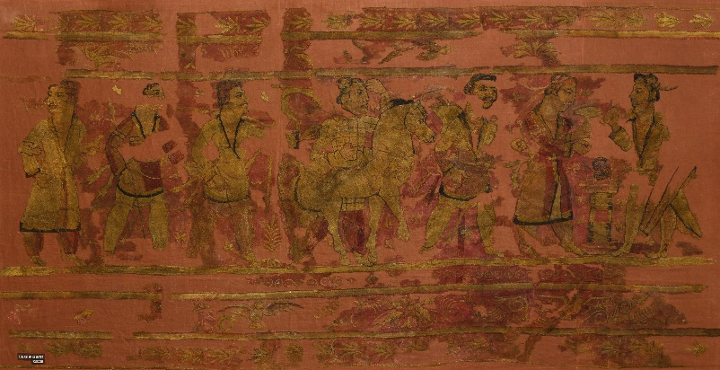

Carpet
Hun period (3rd century BCE – 2nd century CE)
/Institute of Archaeology of Mongolian Academy of Sciences/
Textiles are rarely found in archaeological sites from the Hun period, due to the fact that organic materials completely decompose in soil.

However, the Noin-Ula site is also unique in that a large number of organic artefacts have been relatively well preserved in the semi-permafrost deep in the earth.This embroidered carpet depicting human figures belongs to a unique historical and cultural heritage and is also considered a rare find because it has well-preserved wool fibres and colours which are still visible. The fabric was made in what is now Syria and Palestine, while the embroidery originated in north-west India. The elaborate image woven in woollen thread onto the carpet provides the most valuable information, as it depicts the rites of Zoroastrianism, an ancient religion widespread in India and Iran. The main motif is the offering of the sacred mushroom
over the sacrificial fire. In shape it is similar to well-known psychotropic mushrooms containing the substance psilocybin, which acts on the nervous system. Worshippers of Zoroastrianism believed in an ancient divine spring of living water (soma or haoma) that could be obtained from rare mushrooms and could influence the human psyche. The ritual of the herbal drink called soma occupies a prominent place in the religious worship of the
ancient Indians and Iranians. Another proof that it is Zoroastrians on the carpet is the depiction of warriors marching towards the sacrificial fire. They have a sharp knife strapped to their right leg, a long sword at their left hip, and are dressed in red trousers and traditional Iranian clothing with a loose or close fitting hem on the left arm. Special attention should be paid to the man on horseback, where we can observe the ritual of worshipping the deity from the time of the Achaemenid Empire, which he performs by bringing his left hand close to his forehead. This depiction of a man on horseback is associated with the Indo-Scythian rulers who ruled north-western India from 57 BCE, as well as with their successor, the Indo-Parthian ruler and first monarch of the western and eastern Punjab Gondofar (20–46 CE), on
whose marked silver coins the depiction of a man on horseback is repeated. The clothing and armour of the horsemen depicted on these coins and carpets is the same as that of the Saka and the Parthians. The shape of the saddle resembles that commonly used by early Parthian cavalry, and thus the rugs found in the tombs of nobles at the Noin-Ula site appear to depict Indo-Scythians and Indo-Parthians performing some form of Zoroastrian ceremony.

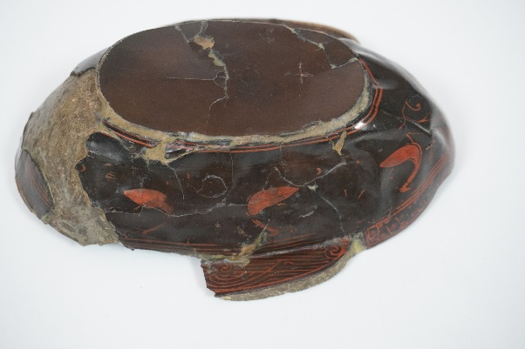

Lacquered bowl
Hun period, 1st century CE
/Institute of Archaeology of Mongolian Academy of Sciences/
More than ten lacquered bowls have been discovered at the Noin-Ula archaeological site. They have an oval shape with a flat bottom and lengthwise handles, which is typical of bowls intended for drinking alcohol. In China, bowls with handles were also made of ceramic, bronze or jade. Some lacquered bowls even have handles reinforced with a bronze band. They are painted red on the inside and brown, red or black on the outside. On the outside there is a painted decoration of pairs of birds facing each other. The birds are separated by squiggles and spirals that represent clouds and phoenixes, mythical creatures symbolizing
the imperial court and, along with the clouds, the space inhabited by “immortals”, beings that dwell beyond the ordinary world. Many bowls bear an inscription in Chinese characters on the bottom. The names of makers from the Chinese imperial workshops are recorded; not only those who carved the bowls, applied the lacquer and painted the decorations, but also
those who inspected and managed the manufacture. In addition to the Chinese inscriptions, the bowls also bear the mark of the Hun families that owned them. During the Han dynasty (206 BCE – 220 CE), the production of lacquerware developed greatly and was especially popular in the southern regions where the lacquer sumach (Toxicodendron vernicifluum) grows. The lacquer was made from sumach sap and used as a waterproof coating. At this time lacquer dyeing was as fashionable as silk. Lacquer objects were among the most valuable artefacts and could only be afforded by persons of high social status. A number of bowls with and without Chinese inscriptions have been discovered at Noin-Ula, as well as at other sites, attesting to cross-cultural and trade exchange between the Huns and the Han dynasty.

Crown
6th–8th century
/Chinggis Khaan National Museum/
The golden crown in the Shoroon Bumbagar tomb is considered a significant archaeological find. Fragments of it were discovered along with other gold artefacts and coins in a burial chamber. The find indicates the high status of the buried person and suggests a cultural link between nomadic peoples and Tang dynasty China. The crown was broken during the funeral ceremony, so its original appearance cannot be completely reconstructed. Nevertheless, the fragments testify to the perfect craftsmanship of the goldsmith. It is made of thin sheet and is decorated with flowers and foliage. The tomb in Shoroon Bumbagar is a unique archaeological site thanks to a number of rare finds, and to its architecture and decoration. Experts still debate who it was intended for. He was probably a Turkic chieftain who had close political relations with the Chinese Tang dynasty.

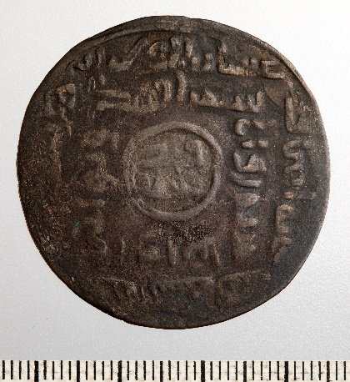

Dirham
Great Mongols, Chinggis Khan (1162–1227 CE)
/Collection of Bedřich Augst (1889–1969), 1963 Náprstek Museum/
Chinggis Khan’s legendary base metal silver plated dirham is revolutionary in many ways in the context of Islamic numismatics. The language used here is fundamental. At this time Persian functioned as a lingua franca throughout central Asia, however, it was not commonly found on minted material. This departure from the far more common Arabic can be considered an extremely rare phenomenon in this context. In the context of the Mongols, however, it has a simple and pragmatic explanation: the quality of the coinage deteriorated sharply as they came to power, and the people apparently refused to accept them. The solution to this problem was to place various warning exclamations on the coins that were intended to be understandable to the widest possible population. Similar quotes can be found on the coins of Ögedei Khan (1186–1241). On one of these coins (also from the Samarqand mint), any refusal to accept official currency is even criminalized.

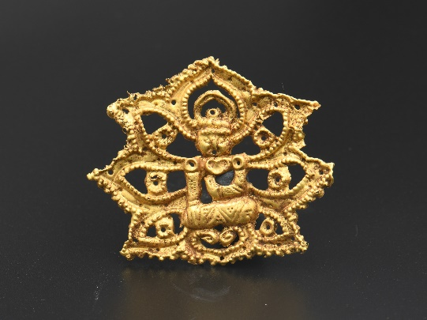

Ornament depicting a seated Buddha
13th–14th century
/Chinggis Khaan National Museum/
Among the finds from the burial site of the Mongolian aristocracy on Khorig Mountain are objects that testify to an awareness of Buddhist teachings. Originating in the 5th century BCE in India, Buddhism spread southward into southern and south-eastern Asia and via trade routes, particularly the Silk Road, into central Asia and China. The Mongols professed shamanism, but they were not opposed to other teachings that they encountered during war
campaigns and trade. Buddhism spread significantly during the Mongol Yuan dynasty. This golden ornament represents the seated Buddha touching the earth with his right hand, calling it to bear witness to his merits and the legitimacy of his enlightenment. The figure is depicted schematically, but with the iconographic details. It is organically connected to the background, which consists of seven leaves, perhaps the petals of the lotus flower. The decoration is prepared by hammering, chiselling and granulation. One can see the small holes along the edges, used for attaching to clothing or a cap.

Photos used: ©Chinggis Khaan National Museum

